**LEBANESE AMERICAN UNIVERSITY**

**USAID – HIGHER EDUCATION SCHOLARSHIP PROGRAM**

**HES - Volunteering Program Verification Form**

This form is to be used to document volunteering hours. If a student volunteers for multiple organizations, a separate form must be used for each organization. **This form must be turned in by the 28th of each month, the latest.**

I certify that the scholar Mahdi Hassan Faraj completed a total of 5 hours of service at Life Sculptor.

The hours were completed hours as per the below:

Hours # 0 (date) _30/09 – 5/10_ (initials of supervisor) __A.K.___

Hours # 0 (date) _7/10 – 11/10_ (initials of supervisor) __A.K.___

Hours # 3 date) _14/10 – 18/10 (initials of supervisor) __A.K.___

Hours # 2 date) _21/10 -25/10 (initials of supervisor) __A.K.___

Brief description of the activities the scholar performed or participated in:

I Conducted a comprehensive research on "The Role of the Arts in Enhancing Education," exploring critical aspects such as the benefits of arts education, its impact on student engagement and creativity, and the role of arts in fostering critical thinking. He included case studies of successful arts integration in schools and addressed the challenges faced in promoting arts programs, along with future trends and strategies for integrating arts into the curriculum. Mahdi also examined the importance of community support and the role of technology in advancing arts education. Following his research, he prepared a detailed PowerPoint presentation summarizing the findings. Additionally, Mahdi developed 8 creative workshop ideas to promote the importance of arts in educational settings, showcasing his ability to translate research into actionable initiatives.

Written feedback about the scholar’s performance:

Mahdi's research on "The Role of the Arts in Enhancing Education" is thorough and insightful. His ability to connect theory with practical workshop ideas showcases his dedication to enriching educational experiences through the arts.

Please rate the overall performance of the scholar at your organization:

|  |  |  |  |
| --- | --- | --- | --- |
|  | Mastery (5) | Proficient (3) | Emerging (1) |
| **Problem solver** | X |  |  |
| **Engaged & Committed** | X |  |  |
| **Open-minded & multicultural** | X |  |  |

Signature

& stamp

__________________________

_

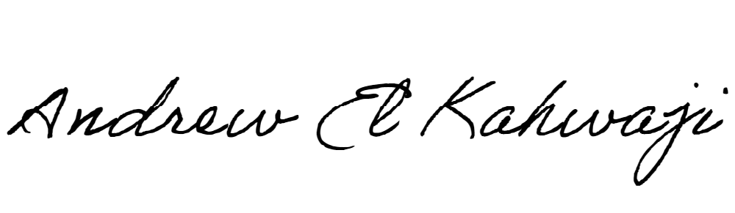

Printed Name _Andrew El Kahwaji_

Date __26/10/2024___

Email __andrew.lifesculptor.coo@gmail.com __

Phone __+961 71 914 378__

**LEBANESE AMERICAN UNIVERSITY**

**USAID – HIGHER EDUCATION SCHOLARSHIP PROGRAM**

